Department of English

RESULT ANALYSIS 2016-22
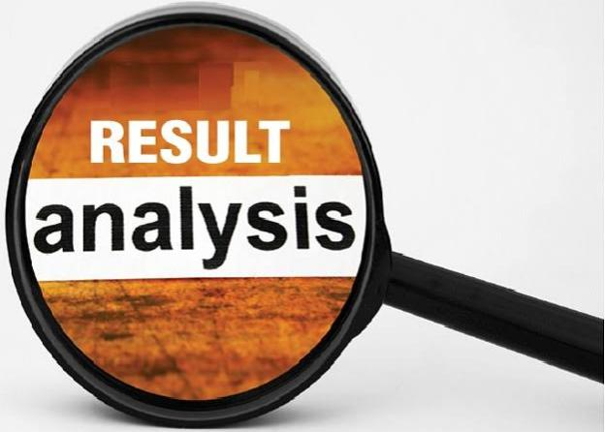
YEAR | NAME OF THE LECTURER | CLASS/ SEMESTER | SBUJECT/ PAPER  THAUGHT | NUMBER  OF  STUDENTS  APPEARED | NUMBER  OF  STUDENTS PASSED | Pass  Percentage  %
2016-  2017 | M. RATNAMOHAN | I  SEMESTER | ENGLISH | 106 | 93 | 87.74
2016-  2017 | M. RATNAMOHAN | II  SEMESTER | ENGLISH | 111 | 101 | 90.99
2016-  2017 | M. RATNAMOHAN | III  SEMESTER | ENGLISH
2017-  2018 | B.USHARANI | I  SEMESTER | ENGLISH | 18 | 8 | 44%
2017-  2018 | B.USHARANI | II  SEMESTER | ENGLISH | 17 | 3 | 18
2017-  2018 | B.USHARANI | III  SEMESTER | ENGLISH | 21 | 09 | 43
2018-  2019 | B.USHARANI | I  SEMESTER | ENGLISH | 89 | 60 | 67.42
2018-  2019 | B.USHARANI | II  SEMESTER | ENGLISH | 75 | 69 | 92
2018-  2019 | B.USHARANI | III  SEMESTER | ENGLISH | 87 | 61 | 70.11
2019-  2020 | A.MEENA | I  SEMESTER | ENGLISH | 91 | 88 | 96
2019-  2020 | A.MEENA | II  SEMESTER | ENGLISH | 80 | 71 | 88.75
2019-  2020 | A.MEENA | III  SEMESTER | ENGLISH | 78 | 62 | 79.48
2020-  2021 | C.NEERAJA | I  SEMESTER | ENGLISH | 71 | 60 | 84
2020-  2021 | C.NEERAJA | II  SEMESTER | ENGLISH | 69 | 64 | 92
2020-  2021 | C.NEERAJA | III  SEMESTER | ENGLISH | 123 | 113 | 91.86
2021-  2022 | U.HEMALATHA | I  SEMESTER | ENGLISH | 147 | 125 | 85.03
2021-  2022 | U.HEMALATHA | II  SEMESTER | ENGLISH | 122 | 112 | 91.8
2021-  2022 | U.HEMALATHA | III  SEMESTER | ENGLISH

